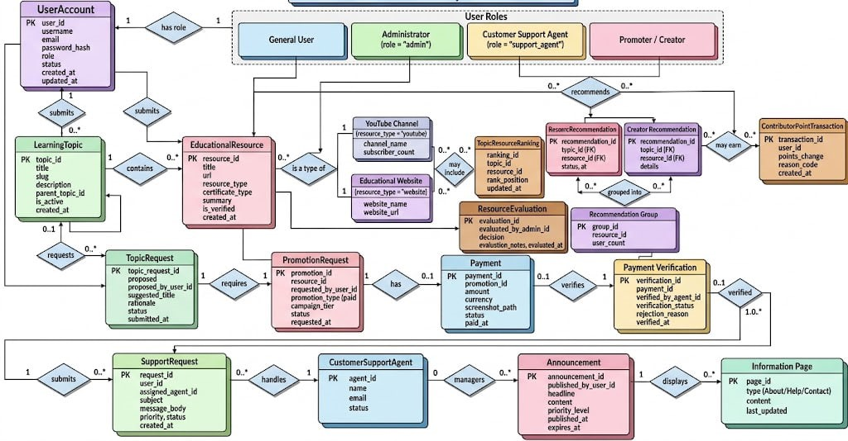

• User Accounts & Roles:
- UserAccount to User Roles (General User, Administrator, Customer Support Agent, Promoter / Creator): One-to-one relationship where each user account has a specific role.
• Content Submissions:
- UserAccount to LearningTopic: One-to-many relationship; a user can submit zero or many learning topics.
- UserAccount to EducationalResource: One-to-many relationship; a user can submit multiple educational resources.
- LearningTopic to EducationalResource: One-to-many relationship where a learning topic contains multiple educational resources.
• Resource Inheritance / Specialization:
- EducationalResource to YouTube Channel / Educational Website: One-to-one subtype relationship (indicated by "is a type of").
• Requests & Payments:
- TopicRequest to PromotionRequest: One-to-one relationship; a topic request requires a promotion request.
- PromotionRequest to Payment: One-to-one relationship; a promotion request has zero or one payment.
- Payment to PaymentVerification: One-to-one relationship; a payment is verified by one payment verification record.
• Support & Management:
- UserAccount (General User) to SupportRequest: One-to-many relationship; a user can submit multiple support requests.
- SupportRequest to CustomerSupportAgent: Many-to-one relationship; support requests are handled by an agent.
- CustomerSupportAgent to Announcement: One-to-many relationship where agents manage announcements displayed on information pages.

